Cara menganalisis Analisis Regresi dengan SPSS

1. Copy Data ke SPSS

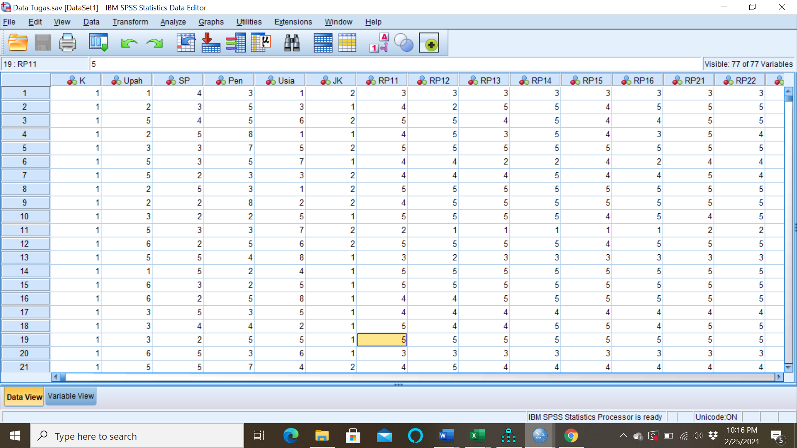

1. Untuk memberi nama variabel pillih variabel view

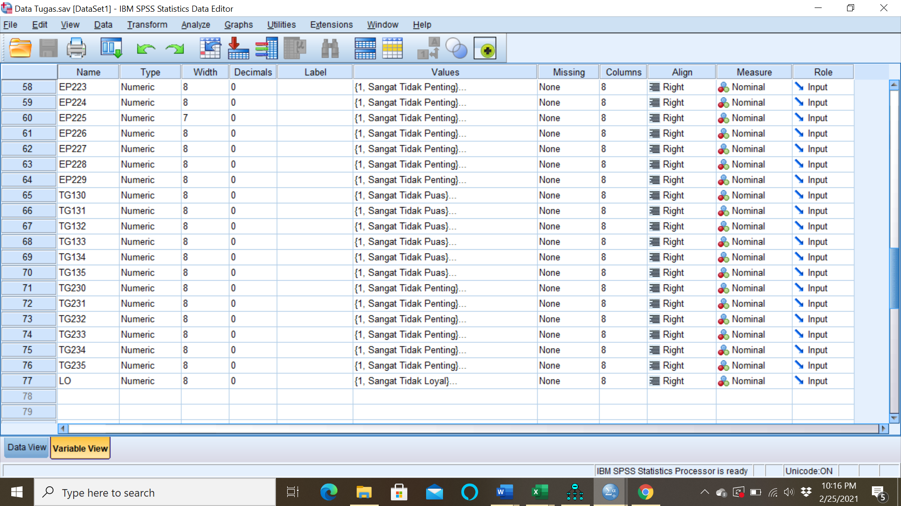

1. Jika sudah 🡪 pilih Analyze 🡪 Regression 🡪 Linear

Didapat hasil sebagai berikut:

|  |  |  |  |  |
| --- | --- | --- | --- | --- |
| **Model Summary** | | | | |
| Model | R | R Square | Adjusted R Square | Std. Error of the Estimate |
| 1 | .132a | .017 | .000 | 1.384 |
| a. Predictors: (Constant), TG135, RV10, RV11, RV12, RV13, RV14, RV19, RV18, RV17, AS116, TG133, TG132, TG134, TG131, TG130, AS115, EP129 | | | | |

R square artinya variabel independen dapat menjelaskan ke variabel dependen sebesar 1,7% sisany 98,3% itu dijelaskan oleh variabel diluar data.

|  |  |  |  |  |  |  |
| --- | --- | --- | --- | --- | --- | --- |
| **ANOVAa** | | | | | | |
| Model | | Sum of Squares | df | Mean Square | F | Sig. |
| 1 | Regression | 33.485 | 17 | 1.970 | 1.028 | .424b |
| Residual | 1881.074 | 982 | 1.916 |  |  |
| Total | 1914.559 | 999 |  |  |  |
| a. Dependent Variable: LO | | | | | | |
| b. Predictors: (Constant), TG135, RV10, RV11, RV12, RV13, RV14, RV19, RV18, RV17, AS116, TG133, TG132, TG134, TG131, TG130, AS115, EP129 | | | | | | |

Hipotesis

H0 = model regresi tidak berarti

H1 = Model regresi berarti

Uji Stat

Dengan sig =.424 > 5% maka Ho diterima 🡪 Model regresi tidak berarti

|  |  |  |  |  |  |  |
| --- | --- | --- | --- | --- | --- | --- |
| **Coefficientsa** | | | | | | |
| Model | | Unstandardized Coefficients | | Standardized Coefficients | t | Sig. |
| B | Std. Error | Beta |
| 1 | (Constant) | 3.662 | .414 |  | 8.839 | .000 |
| RV17 | -.060 | .051 | -.043 | -1.188 | .235 |
| RV18 | -.021 | .046 | -.015 | -.458 | .647 |
| RV19 | -.054 | .031 | -.056 | -1.741 | .082 |
| RV10 | .016 | .031 | .017 | .520 | .603 |
| RV11 | -.021 | .032 | -.021 | -.654 | .513 |
| RV12 | -.040 | .031 | -.041 | -1.300 | .194 |
| RV13 | -.019 | .032 | -.019 | -.587 | .557 |
| RV14 | .013 | .031 | .013 | .412 | .681 |
| AS115 | .082 | .130 | .058 | .633 | .527 |
| AS116 | .046 | .101 | .032 | .451 | .652 |
| EP129 | .127 | .148 | .085 | .857 | .392 |
| TG130 | -.086 | .116 | -.062 | -.745 | .457 |
| TG131 | -.157 | .117 | -.100 | -1.339 | .181 |
| TG132 | .079 | .090 | .057 | .885 | .376 |
| TG133 | .130 | .080 | .094 | 1.629 | .104 |
| TG134 | -.284 | .111 | -.210 | -2.558 | .011 |
| TG135 | .076 | .098 | .054 | .782 | .434 |
| a. Dependent Variable: LO | | | | | | |

Table di atas dapat digunakan menguji keberartian masing-masing variabel independen terhadap variabel dependen. Dilihat dari table diatas dengan nilai sig. <5%

Hipotesis:

H0 = bi = 0 atau variabel independen I (RV17, RV18, …, TG135) tidak memperikan pengaruh terhadap variabel dependen (LO)

H1 = bi ≠ 0 atau variabel independen I (RV17, RV18, …, TG135)memperikan pengaruh terhadap variabel dependen (LO)

Uji Statistik:

Dengan sig =.00 < 5% maka Ho ditolak 🡪 Model regresi berarti

Dari hasil table didapat sig yang < 5% adalah variabel TG134 serta sisanya tidak memberikan pengaruh terhadap Loyalitas.

Dari koefisien regresi di atas dapat digunakan sebagai **Driver analysis dan Critical Technique incidence**

Dari hasil analisis regresi juga terdapat “Excluded variables” yaitu eliminasi pada variabel independen yang akan digunakan dalam pembentukan model. Tujuan eliminasi variabel adalah untuk mendapatkan model terbaik dengan standar error yang kecil. Standar error yang kecil bisa ditandai dengan tidak terjadinya multikolinearitas antar variabel independen.

|  |  |  |  |  |  |  |
| --- | --- | --- | --- | --- | --- | --- |
| **Excluded Variablesa** | | | | | | |
| Model | | Beta In | t | Sig. | Partial Correlation | Collinearity Statistics |
| Tolerance |
| 1 | RP11 | .b | . | . | . | .000 |
| RP12 | .b | . | . | . | .000 |
| RP13 | .b | . | . | . | .000 |
| RP14 | .b | . | . | . | .000 |
| RP15 | .b | . | . | . | .000 |
| RP16 | .b | . | . | . | .000 |
| AS117 | .b | . | . | . | .000 |
| AS118 | .b | . | . | . | .000 |
| AS119 | .b | . | . | . | .000 |
| AS120 | .b | . | . | . | .000 |
| AS121 | .b | . | . | . | .000 |
| AS122 | .b | . | . | . | .000 |
| EP123 | .b | . | . | . | .000 |
| EP124 | .b | . | . | . | .000 |
| EP125 | .b | . | . | . | .000 |
| EP126 | .b | . | . | . | .000 |
| EP127 | .b | . | . | . | .000 |
| EP128 | .b | . | . | . | .000 |
| a. Dependent Variable: LO | | | | | | |
| b. Predictors in the Model: (Constant), TG135, RV10, RV11, RV12, RV13, RV14, RV19, RV18, RV17, AS116, TG133, TG132, TG134, TG131, TG130, AS115, EP129 | | | | | | |