Membuat analsiis descriptive dengan SPSS

1. Buka data SPSS
2. Akan muncul jendela “Welcome to IBM SPSS Statistics

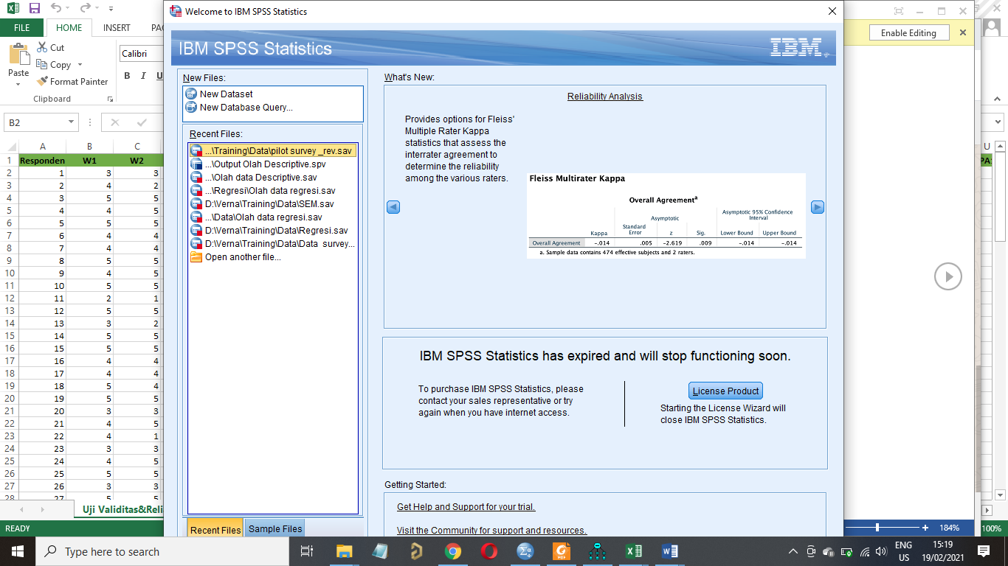

Untuk membuka data baru pilih “**New Dataset”** sehingga muncul tampilan sebagai berikut:

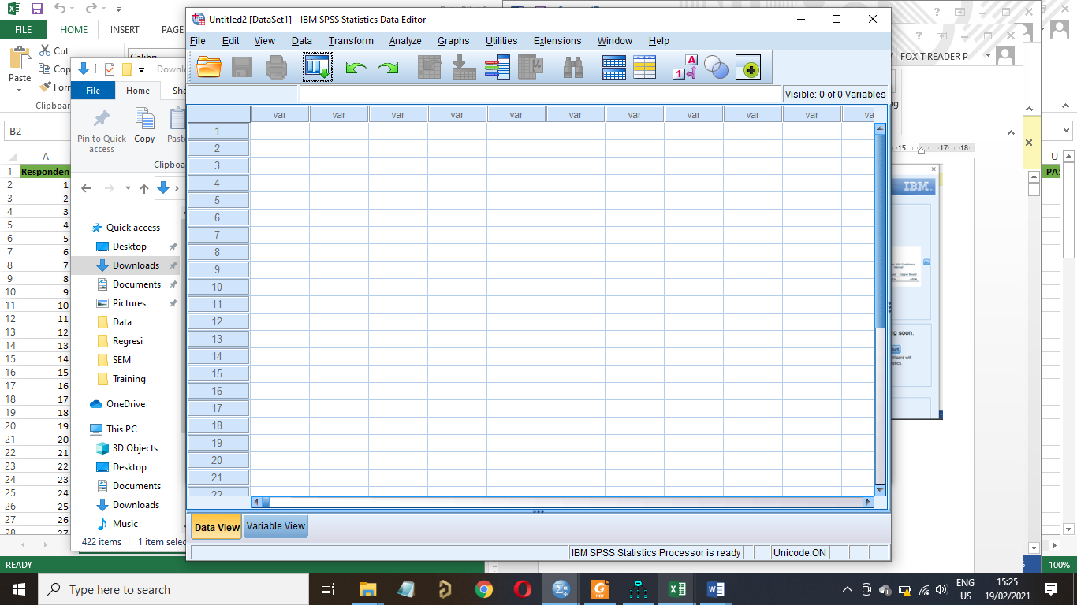

1. Data dari Excel di copy ke aplikasi SPSS

Copy file dari excel diluar variabel dan nomer responden

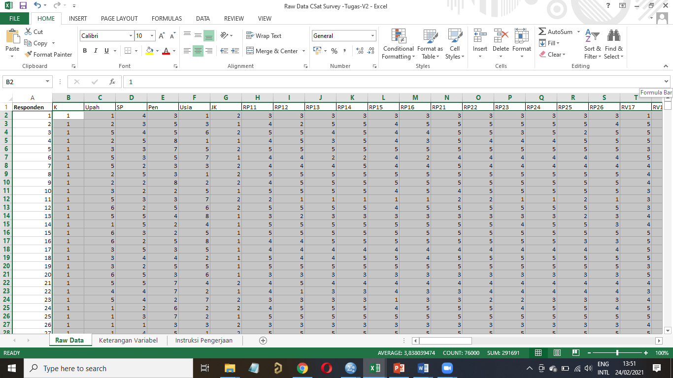

1. Paste data tersebut ke SPSS

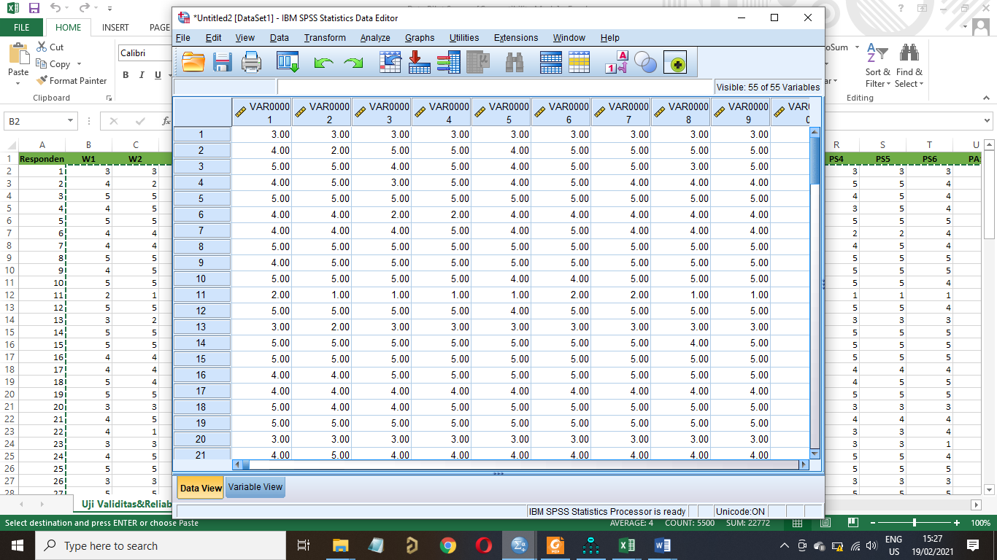

1. Untuk memberi nama variabel pilih **Variabel View**

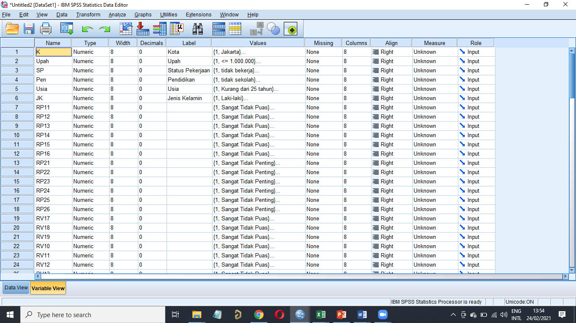

**Analisis deskriptif Top Two Boxes (Skala 4-5), Moderate (Skala 3) dan Bottom Two Boxes (Skala 1-2)**

Klik Analyze 🡪 Descriptive 🡪 Frequencies

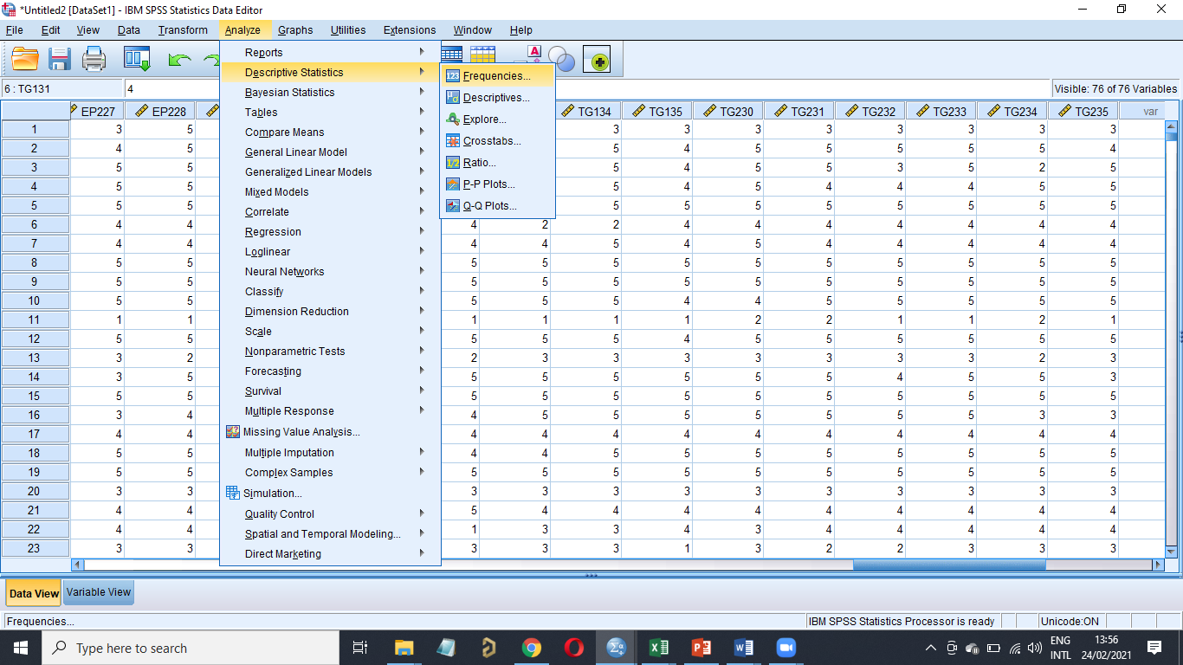

Maka akan keluar

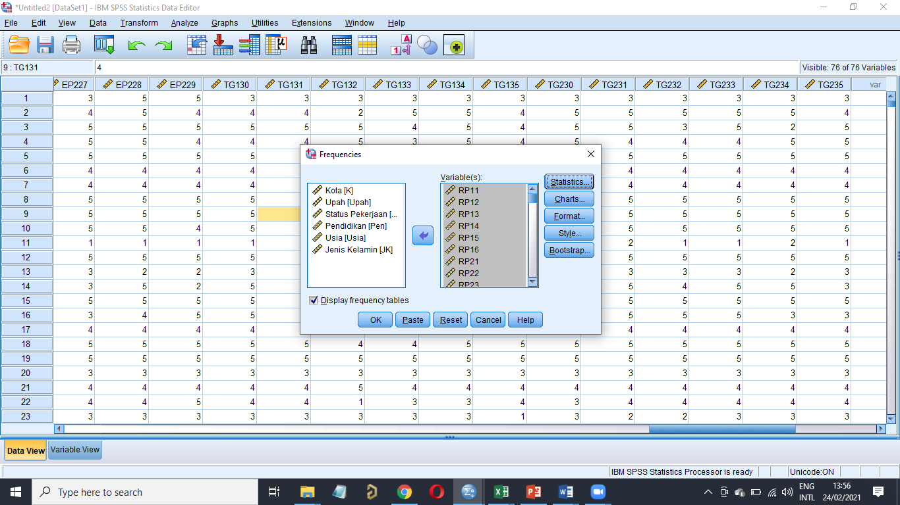

Pidahkan variabel yang akan dianalisis ke kolom **variable(s) 🡪** Lalu klik OK

Maka di jendela Output akan keluar hasils Descriptive frekuensinya sebagai berikut

Untuk mengeluarkan top two boxes dan bottom two boxes maka kita hanya memindahkan variabel-variabel kepuasan

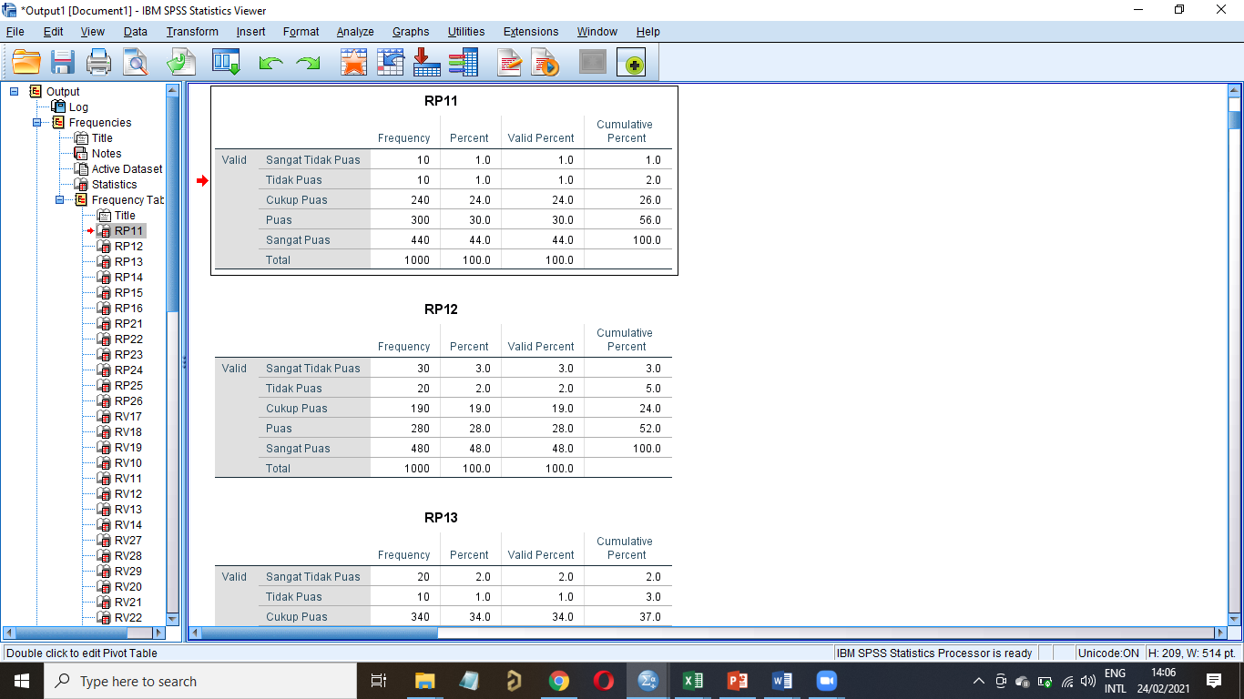

|  |  |  |  |  |  |
| --- | --- | --- | --- | --- | --- |
| **RP11** | | | | | |
|  | | Frequency | Percent | Valid Percent | Cumulative Percent |
| Valid | Sangat Tidak Puas | 10 | 1.0 | 1.0 | 1.0 |
| Tidak Puas | 10 | 1.0 | 1.0 | 2.0 |
| Cukup Puas | 240 | 24.0 | 24.0 | 26.0 |
| Puas | 300 | 30.0 | 30.0 | 56.0 |
| Sangat Puas | 440 | 44.0 | 44.0 | 100.0 |
| Total | 1000 | 100.0 | 100.0 |  |

Dari table frekuesi RP11 atau “***Kehandalan Petugas perusahaan dalam menangani masalah mitra***” diatas dapat disimpulkan bahwa Top two Boxes (puas dan sangat puas) variabel RP11 sebesar 74% (penjumlahan persentase skala 4 dan 5). Untuk yang menjawab moderate (skala 3) ada sebanyak 24% responden dan yang menjawab bottom two boxes (penjumlahan persentase skala 1 dan 2) hanya sebesar 2%.

|  |  |  |  |  |  |
| --- | --- | --- | --- | --- | --- |
| **RP12** | | | | | |
|  | | Frequency | Percent | Valid Percent | Cumulative Percent |
| Valid | Sangat Tidak Puas | 30 | 3.0 | 3.0 | 3.0 |
| Tidak Puas | 20 | 2.0 | 2.0 | 5.0 |
| Cukup Puas | 190 | 19.0 | 19.0 | 24.0 |
| Puas | 280 | 28.0 | 28.0 | 52.0 |
| Sangat Puas | 480 | 48.0 | 48.0 | 100.0 |
| Total | 1000 | 100.0 | 100.0 |  |

Dari table frekuesi RP12 atau “***Kejelasan prosedur santunan***” diatas dapat disimpulkan bahwa Top two Boxes (puas dan sangat puas) variabel RP12 sebesar 76% (penjumlahan persentase skala 4 dan 5). Untuk yang menjawab moderate (skala 3) ada sebanyak 19% responden dan yang menjawab bottom two boxes (penjumlahan persentase skala 1 dan 2) hanya sebesar 5%.

(**lakukan untuk semua variabel tingkat kepuasan**)

Membuat table Cross Sectional

Klik Analyze 🡪 Descriptive 🡪 Crosstabs

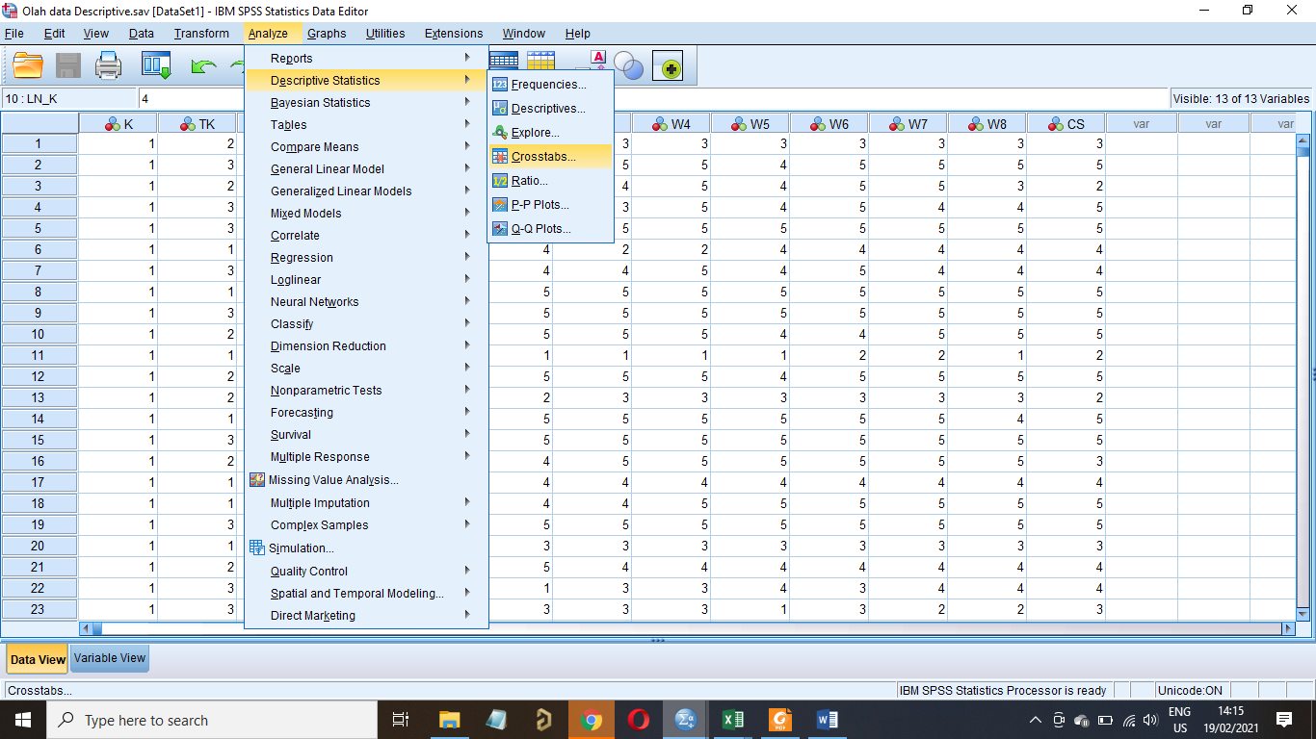

Maka akan muncul jendela Crosstabs sebagai berikut:

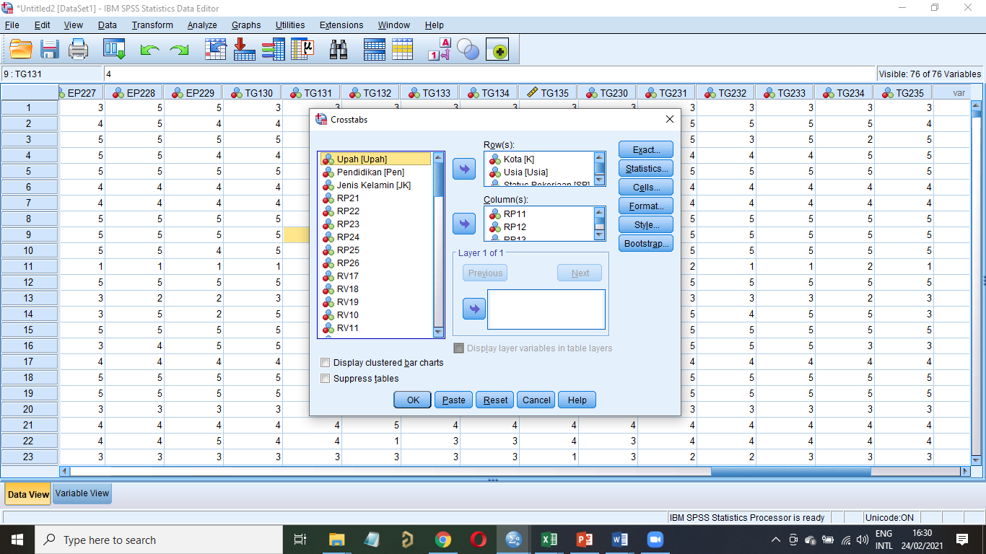

Jika ingin melihat

**Aspek Kehandalan (Reliability)**

Untuk kolom Row bisa dimasukan Kota, Usia, dan pekerjaan

Jika ingin menambah % dimasing2 baris bisa klik Cells dan akan muncul jendela Cell Display.

Centang di Bagian percentages “Row”

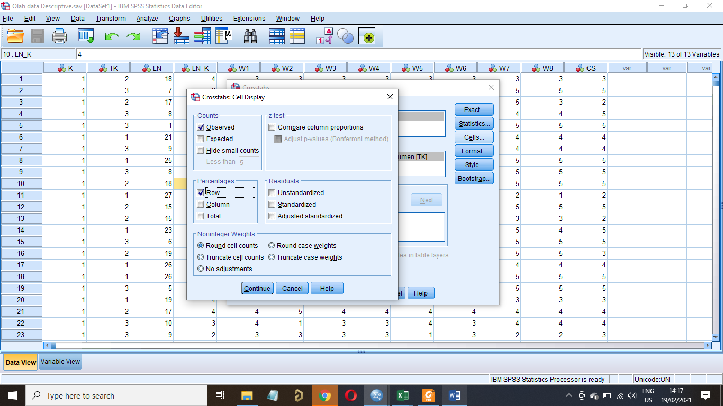

Maka hasil crosstabs berdasarkan

1. kota

|  |  |  |  |  |  |  |  |  |
| --- | --- | --- | --- | --- | --- | --- | --- | --- |
| **Kota * RP11 Crosstabulation** | | | | | | | | |
|  | | | RP11 | | | | | Total |
| Sangat Tidak Puas | Tidak Puas | Cukup Puas | Puas | Sangat Puas |
| Kota | Jakarta | Count | 4 | 4 | 96 | 120 | 176 | 400 |
| % within Kota | 1.0% | 1.0% | 24.0% | 30.0% | 44.0% | 100.0% |
| Bandung | Count | 2 | 2 | 31 | 43 | 72 | 150 |
| % within Kota | 1.3% | 1.3% | 20.7% | 28.7% | 48.0% | 100.0% |
| Surabaya | Count | 2 | 2 | 65 | 77 | 104 | 250 |
| % within Kota | 0.8% | 0.8% | 26.0% | 30.8% | 41.6% | 100.0% |
| Medan | Count | 2 | 2 | 48 | 60 | 88 | 200 |
| % within Kota | 1.0% | 1.0% | 24.0% | 30.0% | 44.0% | 100.0% |
| Total | | Count | 10 | 10 | 240 | 300 | 440 | 1000 |
| % within Kota | 1.0% | 1.0% | 24.0% | 30.0% | 44.0% | 100.0% |

Kesimpulan:

Jika dilihat berdasarkan kota untuk variabel “**Kehandalan Petugas perusahaan dalam menangani masalah mitra**” seluruh kota memiliki tingkat kepuasan yang tinggi dengan rata2 diatas 70% berada pada Top Two Boxes (skala 4 dan 5)

|  |  |  |  |  |  |  |  |  |
| --- | --- | --- | --- | --- | --- | --- | --- | --- |
| **Kota * RP12 Crosstabulation** | | | | | | | | |
|  | | | RP12 | | | | | Total |
| Sangat Tidak Puas | Tidak Puas | Cukup Puas | Puas | Sangat Puas |
| Kota | Jakarta | Count | 12 | 8 | 76 | 112 | 192 | 400 |
| % within Kota | 3.0% | 2.0% | 19.0% | 28.0% | 48.0% | 100.0% |
| Bandung | Count | 6 | 4 | 23 | 39 | 78 | 150 |
| % within Kota | 4.0% | 2.7% | 15.3% | 26.0% | 52.0% | 100.0% |
| Surabaya | Count | 6 | 4 | 53 | 73 | 114 | 250 |
| % within Kota | 2.4% | 1.6% | 21.2% | 29.2% | 45.6% | 100.0% |
| Medan | Count | 6 | 4 | 38 | 56 | 96 | 200 |
| % within Kota | 3.0% | 2.0% | 19.0% | 28.0% | 48.0% | 100.0% |
| Total | | Count | 30 | 20 | 190 | 280 | 480 | 1000 |
| % within Kota | 3.0% | 2.0% | 19.0% | 28.0% | 48.0% | 100.0% |

Kesimpulan:

Jika dilihat berdasarkan kota untuk variabel “**Kejelasan prosedur santunan**” seluruh kota memiliki tingkat kepuasan yang tinggi dengan rata2 diatas 70% berada pada Top Two Boxes (skala 4 dan 5)

|  |  |  |  |  |  |  |  |  |
| --- | --- | --- | --- | --- | --- | --- | --- | --- |
| **Kota * RP13 Crosstabulation** | | | | | | | | |
|  | | | RP13 | | | | | Total |
| Sangat Tidak Puas | Tidak Puas | Cukup Puas | Puas | Sangat Puas |
| Kota | Jakarta | Count | 8 | 4 | 136 | 76 | 176 | 400 |
| % within Kota | 2.0% | 1.0% | 34.0% | 19.0% | 44.0% | 100.0% |
| Bandung | Count | 4 | 2 | 44 | 30 | 70 | 150 |
| % within Kota | 2.7% | 1.3% | 29.3% | 20.0% | 46.7% | 100.0% |
| Surabaya | Count | 4 | 2 | 92 | 46 | 106 | 250 |
| % within Kota | 1.6% | 0.8% | 36.8% | 18.4% | 42.4% | 100.0% |
| Medan | Count | 4 | 2 | 68 | 38 | 88 | 200 |
| % within Kota | 2.0% | 1.0% | 34.0% | 19.0% | 44.0% | 100.0% |
| Total | | Count | 20 | 10 | 340 | 190 | 440 | 1000 |
| % within Kota | 2.0% | 1.0% | 34.0% | 19.0% | 44.0% | 100.0% |

|  |  |  |  |  |  |  |  |  |
| --- | --- | --- | --- | --- | --- | --- | --- | --- |
| **Kota * RP14 Crosstabulation** | | | | | | | | |
|  | | | RP14 | | | | | Total |
| Sangat Tidak Puas | Tidak Puas | Cukup Puas | Puas | Sangat Puas |
| Kota | Jakarta | Count | 12 | 4 | 84 | 52 | 248 | 400 |
| % within Kota | 3.0% | 1.0% | 21.0% | 13.0% | 62.0% | 100.0% |
| Bandung | Count | 5 | 2 | 29 | 17 | 97 | 150 |
| % within Kota | 3.3% | 1.3% | 19.3% | 11.3% | 64.7% | 100.0% |
| Surabaya | Count | 7 | 2 | 55 | 35 | 151 | 250 |
| % within Kota | 2.8% | 0.8% | 22.0% | 14.0% | 60.4% | 100.0% |
| Medan | Count | 6 | 2 | 42 | 26 | 124 | 200 |
| % within Kota | 3.0% | 1.0% | 21.0% | 13.0% | 62.0% | 100.0% |
| Total | | Count | 30 | 10 | 210 | 130 | 620 | 1000 |
| % within Kota | 3.0% | 1.0% | 21.0% | 13.0% | 62.0% | 100.0% |

|  |  |  |  |  |  |  |  |  |
| --- | --- | --- | --- | --- | --- | --- | --- | --- |
| **Kota * RP15 Crosstabulation** | | | | | | | | |
|  | | | RP15 | | | | | Total |
| Sangat Tidak Puas | Tidak Puas | Cukup Puas | Puas | Sangat Puas |
| Kota | Jakarta | Count | 12 | 8 | 104 | 136 | 140 | 400 |
| % within Kota | 3.0% | 2.0% | 26.0% | 34.0% | 35.0% | 100.0% |
| Bandung | Count | 6 | 3 | 33 | 52 | 56 | 150 |
| % within Kota | 4.0% | 2.0% | 22.0% | 34.7% | 37.3% | 100.0% |
| Surabaya | Count | 6 | 5 | 71 | 84 | 84 | 250 |
| % within Kota | 2.4% | 2.0% | 28.4% | 33.6% | 33.6% | 100.0% |
| Medan | Count | 6 | 4 | 52 | 68 | 70 | 200 |
| % within Kota | 3.0% | 2.0% | 26.0% | 34.0% | 35.0% | 100.0% |
| Total | | Count | 30 | 20 | 260 | 340 | 350 | 1000 |
| % within Kota | 3.0% | 2.0% | 26.0% | 34.0% | 35.0% | 100.0% |

|  |  |  |  |  |  |  |  |  |
| --- | --- | --- | --- | --- | --- | --- | --- | --- |
| **Kota * RP16 Crosstabulation** | | | | | | | | |
|  | | | RP16 | | | | | Total |
| Sangat Tidak Puas | Tidak Puas | Cukup Puas | Puas | Sangat Puas |
| Kota | Jakarta | Count | 8 | 4 | 136 | 76 | 176 | 400 |
| % within Kota | 2.0% | 1.0% | 34.0% | 19.0% | 44.0% | 100.0% |
| Bandung | Count | 4 | 2 | 44 | 30 | 70 | 150 |
| % within Kota | 2.7% | 1.3% | 29.3% | 20.0% | 46.7% | 100.0% |
| Surabaya | Count | 4 | 2 | 92 | 46 | 106 | 250 |
| % within Kota | 1.6% | 0.8% | 36.8% | 18.4% | 42.4% | 100.0% |
| Medan | Count | 4 | 2 | 68 | 38 | 88 | 200 |
| % within Kota | 2.0% | 1.0% | 34.0% | 19.0% | 44.0% | 100.0% |
| Total | | Count | 20 | 10 | 340 | 190 | 440 | 1000 |
| % within Kota | 2.0% | 1.0% | 34.0% | 19.0% | 44.0% | 100.0% |

1. Usia

|  |  |  |  |  |  |  |  |  |
| --- | --- | --- | --- | --- | --- | --- | --- | --- |
| **Usia * RP11 Crosstabulation** | | | | | | | | |
|  | | | RP11 | | | | | Total |
| Sangat Tidak Puas | Tidak Puas | Cukup Puas | Puas | Sangat Puas |
| Usia | Kurang dari 25 tahun | Count | 2 | 3 | 36 | 46 | 58 | 145 |
| % within Usia | 1.4% | 2.1% | 24.8% | 31.7% | 40.0% | 100.0% |
| 26 – 29 tahun | Count | 1 | 1 | 39 | 51 | 69 | 161 |
| % within Usia | 0.6% | 0.6% | 24.2% | 31.7% | 42.9% | 100.0% |
| 30 – 35 tahun | Count | 0 | 0 | 58 | 61 | 86 | 205 |
| % within Usia | 0.0% | 0.0% | 28.3% | 29.8% | 42.0% | 100.0% |
| 36 – 39 tahun | Count | 4 | 3 | 37 | 52 | 77 | 173 |
| % within Usia | 2.3% | 1.7% | 21.4% | 30.1% | 44.5% | 100.0% |
| 40 – 45 tahun | Count | 2 | 1 | 37 | 49 | 87 | 176 |
| % within Usia | 1.1% | 0.6% | 21.0% | 27.8% | 49.4% | 100.0% |
| 46 – 49 tahun | Count | 1 | 1 | 9 | 17 | 25 | 53 |
| % within Usia | 1.9% | 1.9% | 17.0% | 32.1% | 47.2% | 100.0% |
| 50 – 55 tahun | Count | 0 | 1 | 12 | 12 | 17 | 42 |
| % within Usia | 0.0% | 2.4% | 28.6% | 28.6% | 40.5% | 100.0% |
| Di atas 55 tahun | Count | 0 | 0 | 12 | 12 | 21 | 45 |
| % within Usia | 0.0% | 0.0% | 26.7% | 26.7% | 46.7% | 100.0% |
| Total | | Count | 10 | 10 | 240 | 300 | 440 | 1000 |
| % within Usia | 1.0% | 1.0% | 24.0% | 30.0% | 44.0% | 100.0% |

Kesimpulan:

Jika dilihat berdasarkan kota untuk variabel “**Kehandalan Petugas perusahaan dalam menangani masalah mitra**” seluruh usia memiliki tingkat kepuasan yang tinggi dengan rata2 diatas 70% berada pada Top Two Boxes (skala 4 dan 5)

**Lakukan untuk seluruh variable tingkat kepuasan**